Week 11 documentation
BIT/2024/73820
Application release preparations
All the debugging codes were removed, the application name set, version numbers updated, app icon set, appropriate permissions set on Camera, local images and GPS and unused resources were eliminated.
The Apk is digitally signed for integral purposes and ready for publishing.
The full app released is made up the following screens:
Introduction page- showcases the app’s logo as an introduction of the app
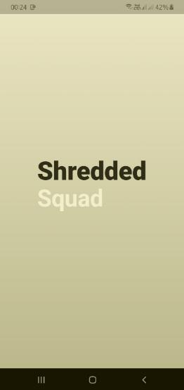

Login page- a page where the user enters their credentials to access the app’s functionalities
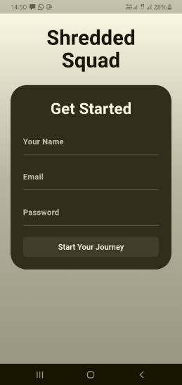
Dashboard/home page- display user name and profile, showing all the capabilities of the app
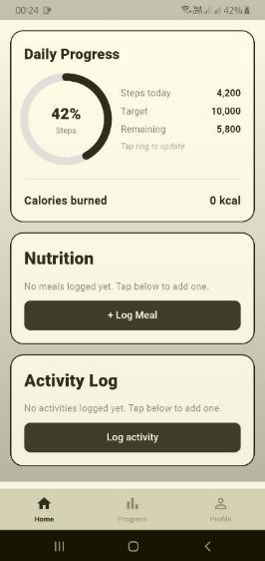

Statistics page- allows the user to track their progress over time through the graph bar and the number of calories they burn through the course of the week
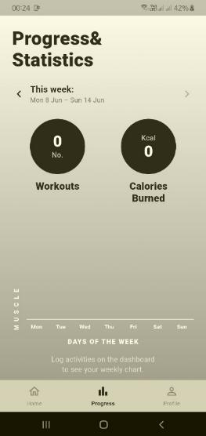
Nutrition screen fetching data from public API
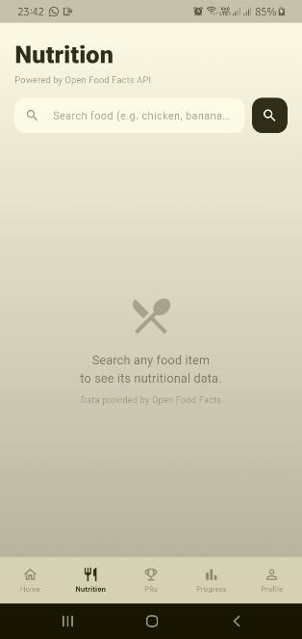

Personal records display screen – Once records are logged in, they are saved in the database and displayed in this screen
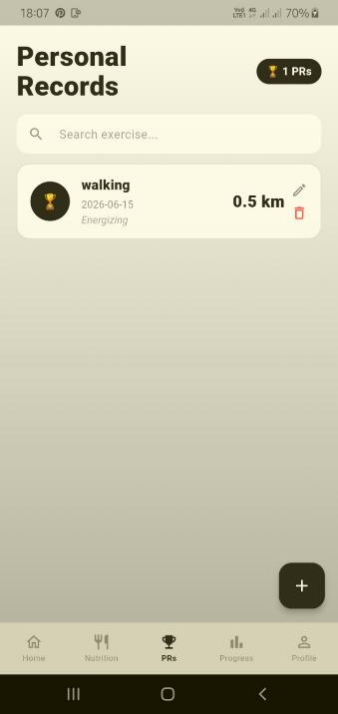

Profile page – allows users to edit their profile by logging their weight, uploading their profile photos and logging out of the app
